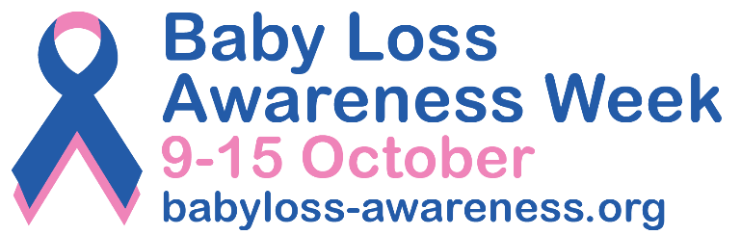

PRESS RELEASE
[Insert date]
[Insert your event/activity headline here] for Baby Loss Awareness Week

[Insert your first name and surname] from [insert name of your town/city] will be [add a short description of your event/activity here] as part of Baby Loss Awareness Week (9 to 15 October).
Every day in the UK, 13 babies die shortly before, during or soon after birth. And there's still much uncertainty around the numbers and rates of pregnancy loss, with evidence suggesting at least 1 in 6 pregnancies end in miscarriage. And there are many other types of loss not included in these numbers, such as ectopic pregnancies, terminations for medical reasons and babies who die due to sudden infant death syndrome.¹

Half of UK adults have said that they, or someone they know, had experienced at least one form of pregnancy or baby loss.²

Baby Loss Awareness Week is an opportunity for everyone in the baby loss community and beyond to come together to remember and commemorate our much-loved and missed babies.

The week also provides an opportunity to raise awareness of the impact of pregnancy and baby loss; the importance that bereavement support plays in the ongoing bereavement journey; and of the vital work that is needed to improve pregnancy outcomes and to save babies’ lives.

The [insert your event/activity here] will take place on [insert date and start and finish times] at [place name]. Delete this paragraph entirely if you are not holding a specific event.

[Insert your name] said: “I/we hope that [insert your event/activity here] will spark conversations about pregnancy loss and baby loss, and give local bereaved parents and families an opportunity to come together to remember and talk about their precious babies.” Please add your own words here if you want to.

From an initiative started by a group of parents 24 years ago, Baby Loss Awareness Week has grown into today’s Alliance of over 140 dedicated pregnancy and baby loss organisations led by Sands, Tommy’s, Bliss, The Ectopic Pregnancy Trust, The Lullaby Trust, and The Miscarriage Association.

Clea Harmer, Chief Executive of Sands and Chair of the Baby Loss Awareness Alliance, said: “Baby Loss Awareness Week is a vital moment in the year to raise awareness of the scale and impact of pregnancy and baby loss. This heartbreak leaves a deep and lasting impact on the lives of so many parents and families, yet we know that it is still not known or spoken about enough.
“It’s also an important time to let anyone touched by pregnancy or baby loss know that there is a community that understands and is here for you, whatever you need – be it guidance, shared real stories or simply a listening ear to help and offer comfort. Everyone can help break the silence, by asking a family member, friend, or work colleague if they would like to talk about their babies and build a world where everyone knows how to find the support they need.
“I hope that [name of the event/activity] will help reassure anyone who finds themselves navigating this journey, whether recently bereaved or longer ago. You are not alone. We’re here for you, always. On behalf of the Alliance, a huge thank you to everyone helping us to have those important conversations about pregnancy and baby loss in compassionate ways.”
Anyone in [insert name of town/city] can share their photos of [insert your event/activity] on social media and include the hashtag #BLAW to reach as many people as possible.
Baby Loss Awareness Week ends with the global ‘Wave of Light’ on 15 October. Everyone is invited, wherever they are in the world, to light a candle at 7pm local time as a special mark of support and remembrance.
The Baby Loss Awareness Week website lists a wide range of organisations that provide a whole range of support, from booklets and leaflets to online groups and help lines, as well as resources and training for health professionals working with and supporting bereaved families.
-Ends-
Contact information

For further information, please contact [insert your first name and surname, phone number and email address].

For further information about Baby Loss Awareness Week email: babyloss@sands.org.uk

Notes to editors

- Every day in the UK, 13 babies die shortly before, during or soon after birth. At least 1 in 6 pregnancies end in miscarriage. Thousands of parents and families are experiencing the heartbreak of pregnancy and baby loss every year in the UK. (Source: Sands) Around 1 in 80 pregnancies is ectopic. (Source: Ectopic Pregnancy Trust). In 2022 there were 3,644 Terminations For Medical Reasons (TFMR) for England, Wales and Scotland. They’re not fully recorded in Northern Ireland yet so there is no accurate figure for the UK (Sources: ONS, Public Health Scotland). Around 1 in 600 pregnancies are molar (Source: Miscarriage Association). In 2022, 189 babies died from SIDS in England and Wales. 9 babies die unexpectedly in England and Wales every week. (Source: Lullaby Trust)
- All figures, unless otherwise stated, are from YouGov Plc. Total sample size was 2121 adults. Fieldwork was undertaken between 14th - 15th August 2023. The survey was carried out online. The figures have been weighted and are representative of all UK adults (aged 18+). Respondents were asked “Which, if any, of the following have you or someone you've known ever experienced, with regards to pregnancy or baby loss? (Please select all that apply.)” The survey was commissioned by an alliance of more than 130 charities led by Sands, Tommy’s, Bliss, The Ectopic Pregnancy Trust, The Lullaby Trust, and The Miscarriage Association.

About Baby Loss Awareness Week
Baby Loss Awareness Week runs from 9th to 15th October every year and is an opportunity for those affected by pregnancy and baby loss and their families and friends to unite with others across the world to commemorate their babies’ lives and lost pregnancies. An initiative started by a group of parents in 2002, it has now evolved into an Alliance of over 140 dedicated pregnancy and baby loss organisations. Whether you're someone who has experienced loss, a family member, friend or healthcare professional, we want you to know this Alliance stands together with you. The charities leading Baby Loss Awareness Week are committed to raising awareness of pregnancy and baby loss in the UK and providing support to anyone affected. By working with health professionals and other organisations, the week aims to drive for improvements in bereavement care and support, and to reduce the incidence of pregnancy and baby loss.
For more information, visit: www.babyloss-awareness.org

