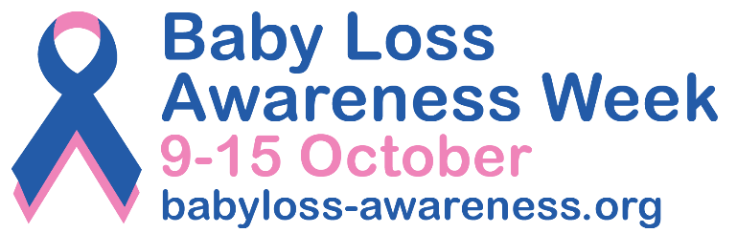

**PRESS RELEASE**

[Insert date]

**[Insert your event/activity headline here] for Baby Loss Awareness Week 2024**

[Insert your first name and surname] from [insert name of your town/city] will be [add a short description of your event/activity here] as part of Baby Loss Awareness Week (9th to 15th October).

Baby Loss Awareness Week, now in its 22nd year, is an opportunity for everyone in the baby loss community and beyond to come together to remember and commemorate our much-loved and missed babies.

The week also provides an opportunity to raise awareness of the impact of pregnancy and baby loss; the importance that bereavement support plays in the ongoing bereavement journey; and of the vital work that is needed to improve pregnancy outcomes and to save babies’ lives.

The [insert your event/activity here] will take place on [insert date and start and finish times] at [place name]. *Delete this paragraph entirely if you are not holding a specific event.*

[Insert your name] said: “I/we hope that [insert your event/activity here] will spark conversations about pregnancy loss and baby loss, and give local bereaved parents and families an opportunity to come together to remember and talk about their precious babies.” *Please add your own words here if you want to.*

Few experiences can compare to the trauma and pain of pregnancy and baby loss. During this Baby Loss Awareness Week, we will acknowledge that finding ways to nurture your mental and physical wellbeing is a vital part of anyone’s bereavement journey.

Clea Harmer, Chief Executive of Sands and Chair of the Baby Loss Awareness Alliance, said: “Following their loss, families find themselves on a new path they never expected to be on. Together, we care for ourselves and each other as part of a community of people affected by all forms of pregnancy and baby loss.

“Grief affects every person differently and can change over time, even during Baby Loss Awareness Week itself. It can be extremely hard for any bereaved person to speak out on the issues that matter to them, if they do not have the time and tools to care for themselves first. Self-care is essential, so you can sustain yourself and be able to raise awareness in a way that’s right for you. 

“I hope that [name of the event/activity] will help reassure anyone who finds themselves navigating this journey, whether recently bereaved or longer ago, that there is a community that understands and is here for you, whatever you need – be it guidance, shared stories or simply a listening ear to help and offer comfort. You are not alone.”  
  
Anyone in [insert name of town/city] can share their photos of [insert your event/activity] on social media and include the hashtag #BLAW to reach as many people as possible.

Baby Loss Awareness Week ends with the global ‘Wave of Light’ on 15 October. Everyone is invited, wherever they are in the world, to light a candle at 7pm local time as a special mark of support and remembrance.

Explore [www.babyloss-awareness.org](http://www.babyloss-awareness.org/) to discover self-care advice and ways you can get involved during the week.

-Ends-

**Contact information**

For further information, please contact [insert your first name and surname, phone number and email address].

For further information about Baby Loss Awareness Week email: [babyloss@sands.org.uk](mailto:babyloss@sands.org.uk)

**Notes to editors**

* *Use this space to add any references or background information if applicable.*

**About Baby Loss Awareness Week**

Baby Loss Awareness Week runs from 9th to 15th October every year and is an opportunity for those affected by pregnancy and baby loss and their families and friends to unite with others across the world to commemorate their babies’ lives and lost pregnancies.

An initiative started by a group of parents 22 years ago, it has now evolved into an Alliance of over 130 dedicated pregnancy and baby loss organisations. Whether you're someone who has experienced loss, a family member, friend or healthcare professional, we want you to know this Alliance stands together with you.

The [charities leading Baby Loss Awareness Week](https://babyloss-awareness.org/charities/) are committed to raising awareness of pregnancy and baby loss in the UK and providing support to anyone affected. By working with health professionals and other organisations, the week aims to drive for improvements in bereavement care and support, and to reduce the incidence of pregnancy and baby loss.

For more information, visit: [www.babyloss-awareness.org](http://www.babyloss-awareness.org)