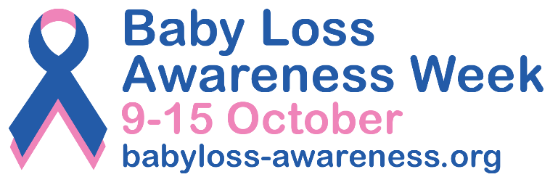

PRESS RELEASE
[Insert date]
[Insert your event/activity headline here] for Baby Loss Awareness Week 2023

[Insert your first name and surname] from [insert name of your town/city] will be [add a short description of your event/activity here] as part of Baby Loss Awareness Week (9th to 15th October).
Baby Loss Awareness Week, now in its 21st year, is an opportunity for everyone in the baby loss community and beyond to come together to remember and commemorate our much-loved and missed babies.

The week also provides an opportunity to raise awareness of the impact of pregnancy and baby loss; the importance that bereavement support plays in the ongoing bereavement journey; and of the vital work that is needed to improve pregnancy outcomes and to save babies’ lives.

The [insert your event/activity here] will take place on [insert date and start and finish times] at [place name]. Delete this paragraph entirely if you are not holding a specific event.

[Insert your name] said: “I/we hope that [insert your event/activity here] will spark conversations about baby loss and give local bereaved parents and families an opportunity to talk about their precious babies.” Please add your own words here if you want to.
Clea Harmer, Chief Executive of Sands and Chair of the Baby Loss Awareness Alliance, said: “Last year, Baby Loss Awareness Week explored the steps that people take along their grief journey, and communities really engaged and resonated with that.
“It gave people the opportunity to explore their own experiences, learn from others and base their Baby Loss Awareness Week activities around that.”
“This year, we are exploring that theme again and we hope that, together, we can reassure anyone who finds themselves on their own grief journey, and we hope that events such as [name of the event/activity] can show that there are communities out there that exist to help, whatever step of your journey you are on.”
Anyone in [insert name of town/city] can share their photos of [insert your event/activity] on social media and include the hashtag #BLAW to reach as many people as possible.

Baby Loss Awareness Week is recognised across the world and culminates with the “Wave of Light” on 15 October. This is a special time when people across the world light a candle at 7pm local time and leave it burning to remember all babies that have died too soon.

Visit www.babyloss-awareness.org to find out how you can get involved.

-Ends-
Contact information

For further information, please contact [insert your first name and surname, phone number and email address].

For further information about Baby Loss Awareness Week email: babyloss@sands.org.uk

Notes to editors

- Use this space to add any references or background information if applicable.

About Baby Loss Awareness Week
Baby Loss Awareness Week runs from 9th to 15th October every year and is an opportunity for those affected by pregnancy and baby loss and their families and friends to unite with others across the world to commemorate their babies’ lives and lost pregnancies.
The charities leading Baby Loss Awareness Week are committed to raising awareness of pregnancy and baby loss in the UK and providing support to anyone affected. By working with health professionals and other organisations, the week aims to drive for improvements in bereavement care and support, and to reduce the incidence of pregnancy and baby loss.
For more information, visit: www.babyloss-awareness.org

