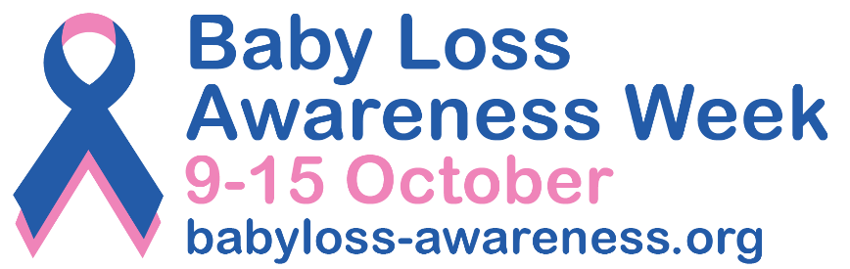

PRESS RELEASE
[Insert date] 2022
[Insert name of building or landmark] is turning pink and blue for
Baby Loss Awareness Week 2022

People in [name of town/city] will see [insert name of the building or landmark] lit up in pink and blue illuminations [add from and to dates] to show its support for Baby Loss Awareness Week 2022 (9th to 15th October).

Baby Loss Awareness Week, now in its 20th year, is an opportunity for everyone in the baby loss community and beyond to come together to remember and commemorate our much-loved and missed babies.

The week also provides an opportunity to raise awareness of the impact of pregnancy and baby loss; the importance that bereavement support plays in the ongoing bereavement journey; and of the vital work that is needed to improve pregnancy outcomes and to save babies’ lives.

[Insert your first name and surname] from [insert name of your town/city], said: “We hope turning [insert the name of the building or landmark] pink and blue will spark conversations about baby loss and give local bereaved parents and families an opportunity to talk about their precious babies.” [Please add your own words here if you want to].
This year Baby Loss Awareness Week will be exploring the theme of Stepping Stones and how someone whose baby has died finds themselves on a new path they never expected to be on.
Clea Harmer, Chief Executive of Sands and Chair of the Baby Loss Awareness Alliance, said: “Following their loss, families find themselves on a new path they never expected to be on. This year, Baby Loss Awareness Week focuses on the steps along that journey, and how they are different for everyone. Some steps along the journey can feel harder than others, but there is always a hand to support anyone when they feel unsteady.
“I hope that [name of the building or landmark] being lit up pink and blue during October will help will help reassure anyone who finds themselves on this journey, whether recently bereaved or longer ago, that there is a community that exists to help with whatever is needed, whether that is advice, support or simply someone to listen and walk by their side.”
All of the buildings and landmarks turning pink and blue for Baby Loss Awareness Week 2022 will be featured on the interactive map and on the official Baby Loss Awareness Facebook page.

Anyone in [insert name of town/city] can share their photos of [insert name of the building] on social media and include the hashtag #BLAW to reach as many people as possible.

Baby Loss Awareness Week is recognised across the world and culminates with the “Wave of Light” on 15 October. This is a special time when people across the world light a candle at 7pm local time and leave it burning to remember all babies that have died too soon.

Visit www.babyloss-awareness.org to find out how you can get involved.
-Ends-
Contact information

For further information, please contact [insert your first name and surname, phone number and email address].

For further information about Baby Loss Awareness Week email: babyloss@sands.org.uk

Notes to editors

- Use this space to add any references or background information if applicable.

About Baby Loss Awareness Week
Baby Loss Awareness Week runs from 9th to 15th October every year and is an opportunity for those affected by pregnancy and baby loss and their families and friends to unite with others across the world to commemorate their babies’ lives and lost pregnancies.
The charities leading Baby Loss Awareness Week are committed to raising awareness of pregnancy and baby loss in the UK and providing support to anyone affected. By working with health professionals and other organisations, the week aims to drive for improvements in bereavement care and support, and to reduce the incidence of pregnancy and baby loss.
For more information, visit: www.babyloss-awareness.org

