

Support for youSands Freephone helpline: 0808 164 3332   
Email: helpline@sands.org.uk  
Ways Sands offers support: sands.org.uk/support

Baby Loss   
Awareness Week

Email: babyloss@sands.org.uk  
[www.babyloss-awareness.org](http://www.babyloss-awareness.org)

#WaveOfLight #BLAW

 

­­­

Wave of Light

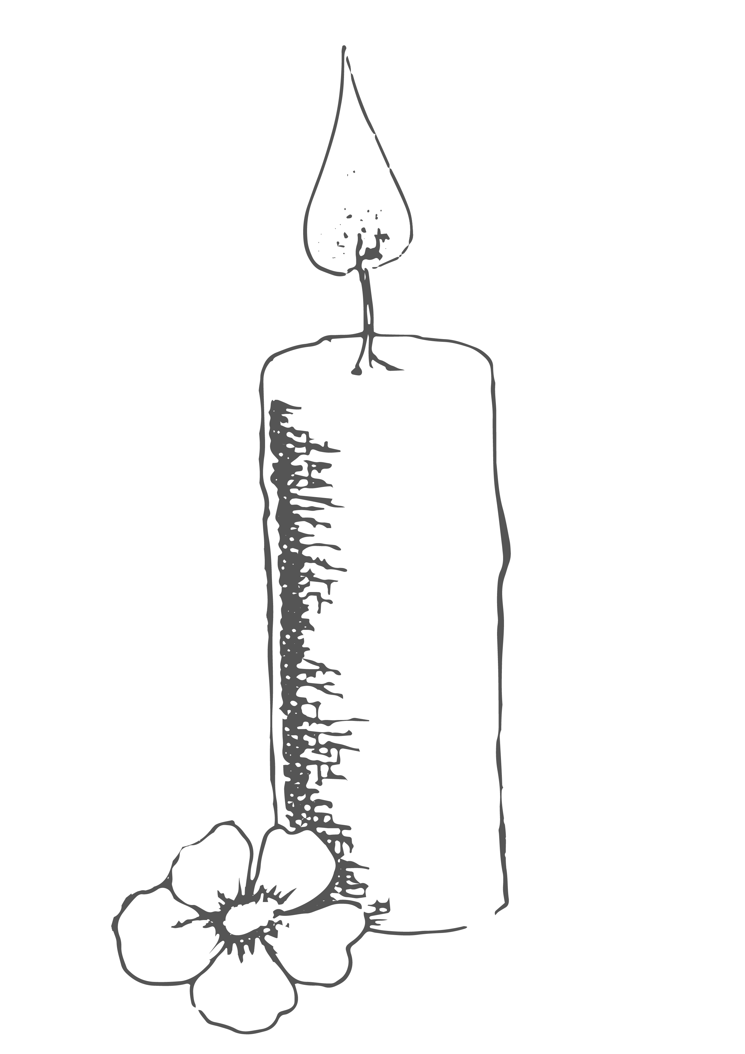

To donate by text, send ‘BABYLOSS 5’ to 70085. This costs £5 plus a standard message rate. You can choose to give any whole amount up to £20 (eg ‘BABYLOSS 20’).   
Thank you so much for your support!

Share your   
#WaveOfLight pictures   
#BLAW

15th October, 7pm

© Sands 2020. Registered as a charity in England and Wales (299679) and in Scotland (SC042789). A company limited by guarantee registered in England and Wales number 2212082.

Morning

Event Time ••• Event details

Event Time ••• Event details

Noon

Event Time ••• Event details

Event Time ••• Event details

Afternoon

Event Time ••• Event details

Event Time ••• Event details

Evening

Event Time ••• Event details

Event Time ••• Event details

To get started right away, select any   
placeholder text (such as this) and  
 start typing to replace it with your own

Welcome

Order of Service